The Jamestown Foundation & the International School of Caucasus Studies
Ilia State University announces:
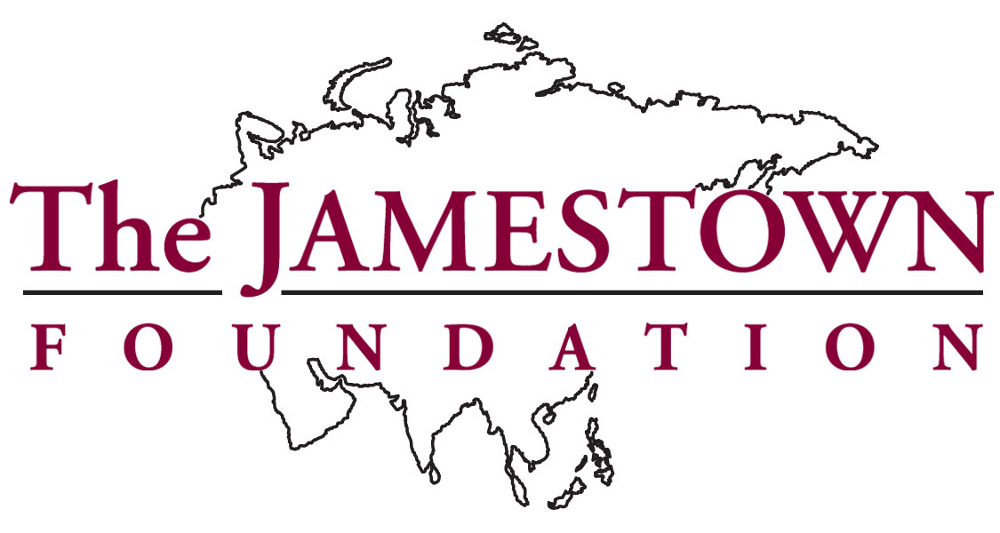

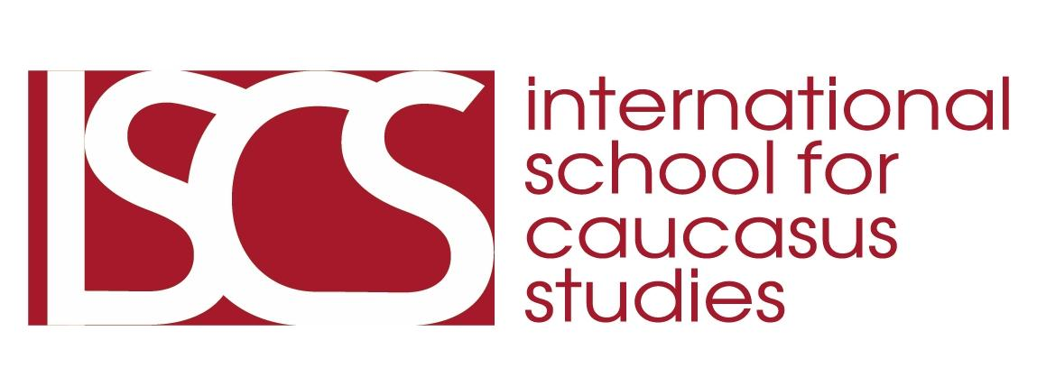

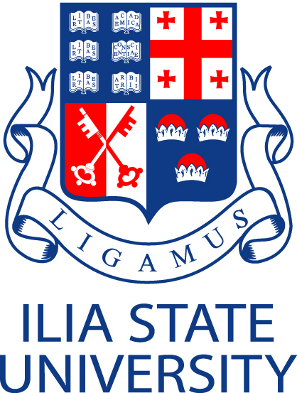

***

Hidden Nations, Enduring Crimes:
The Circassians & the Peoples of the North Caucasus
Between Past and Future

Featuring Keynote Speaker:
Norman Stone
Professor Emeritus Oxford University

Tbilisi, Republic of Georgia

March 20-21, 2010

Courtyard Marriott Hotel - Main Ballroom
DAY ONE:
The Circassians and the North West Caucasus
Saturday, March 20, 2010
9:00 A.M. - 5:00 P.M.
Registration:
8:30 A.M.

Opening Remarks
9:00 A.M. - 9:30 A.M.

Welcome:
Gigi Tevzadze
Rector, Ilia State University
*
Oleg Panfilov
Professor, Ilia State University
*
Andro Barnovi
“Geopolitics and Identity in the Caucasus”
Chairman, STanD
(Institute of Strategy and Development)

Introduction
9:30 A.M.-10:00 A.M.
Ghia Nodia
Director, International School for Caucasus Studies
Ilia State University

Glen Howard
President, The Jamestown Foundation

PANEL ONE:
Political Developments in the Northeast Caucasus
10:00 A.M. to 11:45 A.M.
Fatima Tlisova
“Who Speaks for the Circassians?”
Reagan-Fascell Fellow, National Endowment for Democracy

Murat Gukemukhov
“The Ethno-Political Situation in Karachai-Cherkessk”
Correspondent Kommersant/ RFE/RL
Murat Berzeg
“The Circassian Awakening”
Circassian Congress, Maikop, Adyghea, RF
Ruslan Keshev
Chairman, Circassian Congress,
Nalchik, Kabardino-Balkharia, RF

Q & A

Coffee Break
11:45 A.M. - 12:00 P.M.

Luncheon
12:00 PM-12:30 P.M.
***
Keynote Speaker
12:30 P.M - 1:15 P.M.
Norman Stone
“Remember the Plight of the Circassians”
Professor Emeritus, Oxford University
***

Coffee Break
1:15 P.M. - 1:30 P.M.
PANEL TWO:
Voices from the Circassian Diaspora
1:30 P.M. to 3:15 PM

Ed Youghar
“The Circassian Diaspora in America”
Chairman, Circassian Cultural Institute

Lisa Jarkasi
“Lessons from Vancouver: Opposing the Sochi Olympics”
Patterson, New Jersey
Ali Hadish
“Radio Adiga: The Circassian Voice in Israel”
Radio Adiga
Kfar Kama, Israel
*
Johnny Haghor
"Facts on the Ground in Circassia:
The Land Reclamation Campaign in Kabardino Balkaria”
The Circassian Benevolent Association (Los Angeles)
*
Adel Bashqawi
“The Circassian Diaspora in Jordan: Origins and Future”
Jordanian Association of Caucasus Circassian Friends
Q & A
Coffee Break
3:15 P.M. - 3:30 P.M.
*
PANEL FOUR:
The Circassians in History
3:30 P.M. to 5:00 P.M.
Moshe Gammer
“Population Transfers in the North Caucasus: 1774 - 1944”
*
Yahya Khoon
“Muhammad Amin: Shamyl's Messenger to the Circassians”
*
Ali Berzeg
“New Historical Research Findings on the Circassian Genocide
from the Russian Imperial Archives in Tbilisi”
Research Director, Circassian Cultural Institute
*
Niko Javakhishvili
"Georgian Sympathy for the Plight of the Circassians in the Times of Trouble in the Latter Half of the 19th Century"
Professor, Institute of Georgian History
Ivane Javakhishvili State University
Q & A
END DAY ONE:
5:00 PM
DAY TWO:
The North East Caucasus: Chechnya, Dagestan, and Ingushetia
Sunday, March 21, 2010
9:00 A.M. - 3:30 P.M.
PANEL ONE:
History of the 19th Century
9:00 A.M. to 10:30 A.M.
Moderator:
Moshe Gammer
Tel Aviv University
Abusmuslimov Said-Khasan
“On the Question of the Historical, Social, Psychological, Political and Legal Aspects of the Chauvinist Crimes of the Great Russian State against the People of the North Caucasus”
Donogo Khadji Murad
“Russian Policy in Dagestan from the Colonial Period to the Soviet Period Totalitarianism”
Dagestani journalist and historian

Maria Bennigsen
“Insurgencies in Dagestan and Chechnya in the Soviet Period”
Historian and expert on the Caucasus
Mairbek Vatchagaev
“The Impact of Russian Colonization on the Chechen People in the 19th and 20th Centuries”
Historian and Analyst
Q & A

Coffee Break
10:30 A.M. to 10:45 AM

PANEL TWO:
Political and Human Rights Developments in Chechnya & the Northeast Caucasus
10:45 A.M. to 12:00 P.M.
*
Andrei Babitsky
“The Downward Spiral of the North Caucasus”
Radio Free Europe
*
Valery Dzutsev
“Russian Policies toward the North Caucasus”
Analyst, Jamestown Foundation
*
Sophie Shihab
“Chechnya under Kadryov”
Le Monde
*
Anzor Maskhadov
“The War in Chechnya and the Plight of Chechen Refugees in Europe”
Chechnya Foundation for the Caucasus, Norway

Luncheon
12:00 P.M. - 12:30 P.M.
***
Keynote Speaker:
12:30 P.M. - 1:15 P.M.
Vafa Guluzade
“Russia’s Future in the North Caucasus”
Former National Security Adviser,
President Heidar Aliyev
***
Coffee Break
1:15 P.M. - 1:30 P.M.
PANEL THREE
Human Rights Developments in the North Caucasus
1:30 P.M. to 3:30 PM
*
Taisa Isaeva
Human rights activist, Memorial
Chechnya
*
Larisa Dorogova
Human rights activist - Kabardino-Balkharia
Svetlana Isaeva
The Mothers of Dagestan
*
Ella Kesaeva
Voices of Beslan
*
Larisa Kudzieva
Voices of Beslan

Q & A
Closing Remarks
Ghia Nodia

END
3:30 P.M.

BIOS

Andro Barnovi

Andro Barnovi heads the Tbilisi based Institute of Strategy and Development. He specializes in international relations, defense and security policy and conflict studies. Mr. Barnovi graduated from Georgian and American universities with the MA equivalent in classical studies and dual MS in defense analysis and national security affairs. He also graduated of RAND public policy courses. Mr. Barnovi’s professional experience includes four years in Tbilisi State University, four years working in the Georgian Ministry of Defense and later served in General Staff of the Georgian Armed Forces. He also served two years in the Georgian parliamentary committee on Defense and Security, three years in Georgian Institute of Public Affairs and four years as the head of the Institute of Strategy and Development where he currently serves as chairman of the board.

Adel Bashqawi

Adel Bashqawi was born in Amman, Jordan, from a Circassian family. Mr. Bashqawi studied and worked in the aviation sector, with a military background as an officer in the Jordanian Armed Forces. He studied and attended courses in Jordan, the United States, and the United Kingdom. His areas of interest concern the Circassians and the North Caucasus, and has conducted an active role in writings and translations that are concerned with the Circassian people. He has participated in numerous conferences and seminars concerning the plight of the Circassians around the world, including Jordan, the Untied States and Europe. He has given presentations at William Paterson University, and the Jordanian Circassian Charity Association.

Khadji Murad Donogo

Khadji Murad Donogo is a historian, journalist, and doctor of sciences and the editor-in-chief of he journal “Akhulgo. He is the author of numerous books and publications concerning the history of Dagestan and the North Caucasus.
Larisa Dorogova
Larisa Dorogova lives in Nalchik, Kabarda-Balkaria and is a lawyer who specializes in cases of missing persons and people illegally convicted on religious grounds.
Valeriy Dzutsev

Valeriy Dzutsev is a freelance analyst writer, who covers developments in the North Caucasus for the Washington based Jamestown Foundation and several other online publications. Valeriy received an Edmund S. Muskie Fellowship in 2007, supported by the U.S. Department of State and received his master's degree in Public Policy at the University of Maryland in 2009, with specialization in International Security and Economic Policy. From 2002-2007 Mr. Dzutsev worked for the distinguished British journalism development organization: The Institute for War and Peace Reporting as country director for the North Caucasus. Mr. Dzutsev extensively reported and edited journalistic materials from across the North Caucasus on events like the Beslan school hostage taking in North Ossetia in 2004, the violent assault on Nalchik in Kabardino-Balkaria by armed militants in 2005 and overall socio-political developments in the region. Before working for IWPR, Valeriy served as a local coordinator for another British-based NGO Centre for Peacemaking and Community Development (CPCD) in North Ossetia, managing numerous conflict transformation projects.

Moshe Gammer

Moshe Gammer is Associate Professor at the Department of Middle Eastern and African History, Tel Aviv University. He is the author of Muslim Resistance to the Tsar: Shamil and the Conquest of Chechnia and Daghestan (London: Frank Cass, 1994) and The Lone Wolf and the Bear. Tree Centuries Chechen Defiance of Russian Rule (London: C. Hurst & Co .and Pittsburgh: University of Pittsburgh Press, 2006) and many articles on the history and contemporary affairs of the Caucasus, Central Asia and the Middle East.
Vafa Guluzade
Vafa Guluzade is the former national security adviser to the President of Azerbaijan, Heidar Aliyev. He was born on December 22, 1940 in Baku, Azerbaijan. Mr. Guluzade graduated from high school in 1958 and from the Azerbaijan State University in 1963. Later he worked for Azerbaijani radio as an editor at the foreign desk. He was accepted to the Institute of Middle Eastern Studies of the USSR Academy of Sciences in Moscow and studied there for three years. He did his graduate work on modern Egyptian literature and received an M.A. degree in 1968.
Mr. Guluzade began his diplomatic career in 1969 as an attaché at the Ministry of Foreign Affairs of the USSR and later was promoted to the second secretary of the Soviet Embassy in Egypt. After service in Cairo, he was transferred to the Middle Eastern Department of the Ministry of Foreign Affairs in Moscow. Speaking fluent Russian and Arabic, Mr. Guluzade interpreted for Anwar Sadat, President of Egypt, Hafez Asad, President of Syria, also for Leonid Brezhnev, Alexei Kosygin, Andrei Gromyko, Andrei Grechko and other senior Soviet officials.
His personal acquaintance with Azerbaijani President Heydar Aliyev dates back to 1973, when Mr. Aliyev headed a Soviet delegation to Egypt. At the end of 1975, Heydar Aliyev, then First Secretary of the Azerbaijan Community Party, invited him to Baku and appointed him as the head of the Department of Culture in the Central Committee of the Azerbaijan Community Party.
From November 1990 until October 1999 Mr. Guluzade served as an Advisor and Counselor on Foreign Policy Matters to three consecutive Presidential Administrations in Azerbaijan (Mutallibov, Elchibey and Aliyev). During that period Mr. Guluzade was a constant member of the State Security Council. He was the Chief Negotiator and representative of President Aliyev on negotiations with Armenia on Nagorno-Karabakh issue.
He is a recognized expert on the issues of the Commonwealth of Independent States and in particular, Russia and the Caucasus. He published numerous articles in newspapers analyzing the policy of Russia in the Caucasus. Mr. Guluzade is known as an advocate of pro-Western orientation of Azerbaijan, and was characterized by the U.S. State Department as "the architect of pro-Western orientation of Azerbaijan." In 1999, he was the first to declare the idea to place NATO military bases in the Caucasus. This caused uproar in a number of well-known newspapers and publications, and triggered sharp reactions in Russia and also in Iran.
In October 1999 due to disagreements on key foreign policy issues with the then leadership, he resigned from the position of the Foreign Policy Advisor for the President of Azerbaijan and established the Caspian Policy Studies Foundation. Mr. Guluzade has lectured widely in the United States, speaking at Harvard University, Columbia University and Johns Hopkins University. He is the author of two books dedicated to the issues of Russia, the Caucasus and Turkey, and conflicts on these territories.
Ali Hadish
Ali Hadish works for Radio Adiga and lives and works in Kfar Kama, Israel.
Taisa Isaeva
Taisa Isaeva lives in Groznyy, Chechnya and is a well-known Chechen public figure. She has covered violations of rights of Chechens during the second military campaign, and is the head of the Council of Nongovernmental Organizations.
Lisa Jarkasi
Dr. Lisa Jarkasi is one of the founders of the No Sochi 2014 Committee, www.nosochi2014.com. She is active in the Circassian community and is a member of the Circassian Cultural Institute located in Patterson, New Jersey. Dr. Jarkasi received a Doctorate of Pharmacy degree from Rutgers University.
Niko Javakhishvili
Niko Javakhishvili is a doctor of historical sciences and a professor at the Institute of Georgian History at the Ivane Javakhishvili State University. He also works as a chief researcher in the Department of Modern and Contemporary History at Ivane Javakhishvili Institute of History and Ethnology. His research is about auxiliary historical fields: faleristics, bonistics, heraldics, genealogy and historical questions of Georgian relationship with other countries. He has over 100 publications in Georgian, English, German, Polish, Armenian and Russian languages.
Ella Kesaeva
Ella Kesaeva is the chairwoman of Golos Beslana (“Voice of Beslan”) nongovernmental organization, and a public figure in Ossetia actively involved in investigating the crime committed in Beslan in 2004 during the school siege in which children were taken hostage. She currently lives in Vladikavkaz, North Ossetia, Russian Federation.
Ruslan Keshev

Keshev Ruslan is chairman of the Kabardino-Balkarian regional organisation "The Circassian Congress. An ethnic Circassian he was born in Nalchik the Kabardino-Balkarian Republic, Russia. From 1988-1989 he served in the Soviet army. In 1992 has with distinction ended the Kabardino-Balkarian State University. Specialized on chair of theoretical physics. From 1992 to 2006 he was a teacher of physics at schools, university, and an institute. Now he is a senior teacher of the chair of natural-mathematical formation. Publications on problems of radiation of ultrarelativistic particles. In 2006 he was recognized as the winner of competition of the best teachers of the Russian Federation. He has been in the Circassian national movement since 1989. During the Georgian-Abkhazian war - аt the Congress of the Kabardian people on work of radio stations on communication with Abkhazia. From September 2006 to the present he has served as the chairman of the Kabardino-Balkarian regional organisation "The Circassian Congress."

Yahya Khoon

Yahya Khoon is a PhD student at the Department of Middle Eastern Studies, Haifa University. He is currently completing his dissertation on Muhammad Amin, Imam Shamil’s Emissary to the Circassians. The topic of his dissertation is: “Sufism and Resistance: Muhammad Amin and the Circassian Anti-Colonial Struggle in the Northwest Caucasus in the mid 19th century and his PhD advisers are Professors Moshe Gammer &. Itzchak Weismann.
Larisa Kudzieva
Larisa Kudzieva is a member of the Golos Beslana (“Voice of Beslan”) nongovernmental organization and lives in Vladikavkaz, North Ossetia, Russian Federation.
Murat Gukemukhov
Murat Gukemukhov is an expert on the North Caucasus and works as a correspondent for Kommersant newspaper and as an analyst for Radio Free Europe. Based in Cherkessk, the capital of the North Caucasus Republic of Karachaevo-Cherkesia, Mr. Gukemukhov has worked as a reporter and analyst since 1998. Mr. Gukemukhov has worked as a reporter and analyst for numerous media outlets including the TV channel – NTR (Cherkessk), and the Russian news agency Regnum. Mr. Gukemukhov’s publications, analyses and reports frequently appear in Ekho Moskvy, Radio Free Europe/Radio Liberty, the Institute for War and Peace Reporting, Vremya MN, and Novoye Izvestia. Mr. Gukemukhov has participated in numerous international forums, including a 2008 conference organized by the Center for Strategic Studies in Tbilisi, Georgia. Mr. Gukemukhov is an official representative of the Caucasus Forum of NGO in Karachaevo-Cherkesia, supported by International Alert, London, United Kingdom.
Ghia Nodia

Ghia Nodia is the professor of politics and the director of the International School of Caucasus Studies in Ilia State University in Tbilisi, Georgia. He is also a founder of the Caucasus Institute for Peace, Democracy and Development (CIPDD), an independent public policy think tank in Tbilisi, Georgia, which he led in 1992-2008 and leads again since August 2009. He has published extensively on two sets of topics: regional security, state-building and democratization in the Caucasus, and theories of nationalism and democratic transition in the post-cold-War context. He has been involved in pro-democracy advocacy efforts in Georgia and internationally, and has been frequent participant of international congresses and conferences on the related topics. In February-December 2008, he served as the minister of education and science of Georgia.

Sophie Shihab

Sophie Shihab is regional correspondent for Le Monde, and has been based in Istanbul since 2005. She has traveled widely throughout the North Caucasus and reported on the conflict there since the mid-1990s.

Fatima Tlisova

Fatima Tlisova is an award-winning investigative reporter with extensive experience in the conflict-ridden North Caucasus. Over the past decade, she has covered the most sensitive topics affecting the region, including human rights violations, torture and detention, women’s rights, nationalist sentiments, the role of Islam in regional affairs, and abuses of power by authorities. She served as editor-in-chief of the Regnum News Agency from 2004–2007 and has reported for Russia’s Novaya Gazeta, the Associated Press, the Institute for War and Peace Reporting (IWPR), the Jamestown Foundation, and Radio Free Europe/ Radio Liberty. Most recently, Ms. Tlisova was a Carr Center Fellow and a Nieman Fellow at Harvard University. She is a recipient of the Gerd Bucerius Freedom of Expression Award for her commitment to reporting on the conflict in Chechnya, the Amnesty International UK Media Award, the Rory Pack Trust Award, the Human Rights Watch Hellman-Hammett Award, The Louis Lyons Award for Conscience and Integrity in Journalism. During her fellowship, Ms. Tlisova plans to complete reports on the state of journalism in the North Caucasus and work on a book documenting abuses and describing how the suppression of human freedoms contributes to the spread of violence in the region.

Mairbek Vachagaev

Mairbek Vachagaev is an analyst, historian and specialist on the North Caucasus. He writes a weekly column for the Jamestown Foundation publication Eurasia Daily Monitor on the situation in the North Caucasus. He is the author of several articles and book on the North Caucasus and the history of Chechnya and Sufism in the Caucasus. He is the chief editor of the online journal Prometheus (www.chechen.org).

Iyad Youghar

Iyad Youghar is the founder of the Circassian Cultural Institute which created in 2004. He is the former Vice-President of the Circassian Benevolent Association (Adigha Khasa) in the United States of America. He holds an engineering degree and presently operates a corporate security company based in New Jersey.

