Circassia today, Circassia tomorrow
Circassia today and Circassia tomorrow. What do we mean when speaking about Circcassia? Some people understand it as a historical, or even a geographical term. Circassians look at it in terms of political meanings. Obviously, different people representing different interests would imply different and often contradictory meanings to the term Circassia.
The Russian official view on the past of Circassia is presently based on denial of Circassians’ indigenousness, erroneusly referring to the nomadic character of Circassians. In other words, Circassia, for modern official historians and analysts in Russia, is a term that is to be avoided, if mentioned at all. Russia rarely includes any sense of a unified country and never with stately connotations. This was most clearly proclaimed by Putin in his greeting Olympic speech to IOC, when proclaiming ancient Greeks to be the real native people of the territory known to the world as Circassia.
In contrary to that, all the historical accounts on the past prove that Circassia was an unified country with its original republic-like governing state system, with efficiency in administering its policies, which could be compared with many other contemporaries of those times.
Circassia today. Three Republics.
The shape of present Circassia within the Russian Federation represents 3 semi-autonomous Republics, formed after the Bolshevick Revolution: Adyghea, Karachaevo-Cherkessia and Kabardino-Balkaria. Officially, it is recognized that 7 different indigenous ethnicities comprise those 3 republics. Adigeytsi in Adyghea Republic, Karachayevtsi, Cherkesi, Abazini and Nogaytsi in Karachayevo-Cherkessia, and Kabardintsi and Balkartsi in Kabardino-Balkaria. In reality however there should be (and was before Russians) only 3: Abaza, Adyghe, and Karachay-Balkars, which lived together in Circassia for centuries before the genocide that the Russians committed against Abaza and Adyghes.
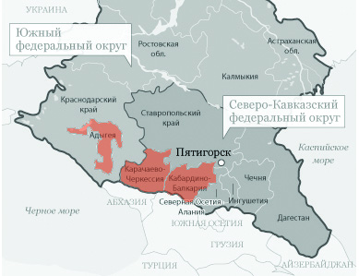
Two of the republics, Karachayevo-Cherkessia and Kabardino-Balkaria are sharing border. Each of them, combine 2 major native ethnic groups, Karachays with Cherkes and Kabardians with Balkars respectively. While Karachays and Balkars speak the same Turkic language, Cherkes with Kabardians are actually one ethnicity (with endonym адыгэ), both speaking an identical Kabardian dialect. It’s absolutely clear that such distribution of the ethnicities was done with the aim to better “divide and rule” them. Adyghea has only one titular native ethnicity, in Russian officialese, Adygheytsi, or in reality Circassians, who speak western dialects. The fact that Circassians are not confronted with any other native ethnicities in Adyghea, appears to be one of the reasons for attempts to eliminate Adyghea as a republic in 2006. Additionally to all, Adyghea, as a part of the Southern Federal District, is separated from KBR and KCR which were included into the North Caucasian federal District.

Processes in Russia
Being administratively and politically subjected to Putin’s Russia, all three Circassian republics factually have only their names. There are almost no expressions of political self-determination, which normally supposed to be present in a state with a federal system of governing.
Being deprived to manifest themselves officially Circassians in the Caucasus, unlike with the ones in Diaspora, are waiting for the changes to come within the whole of Russia herself.
We are the witnesses of processes taking place in modern Russia. Latest happenings there don’t leave any doubts that North-Caucasian republics won’t stay within Russian rule for long. The slogan “Enough feeding the Caucasus” spreads in Russian society. Moreover, now we even can hear voices about further inexpediency to be part of corrupted the Moscovite state from ethnically Russian regions. One of the examples is Federal Republic of Bigger Ural.
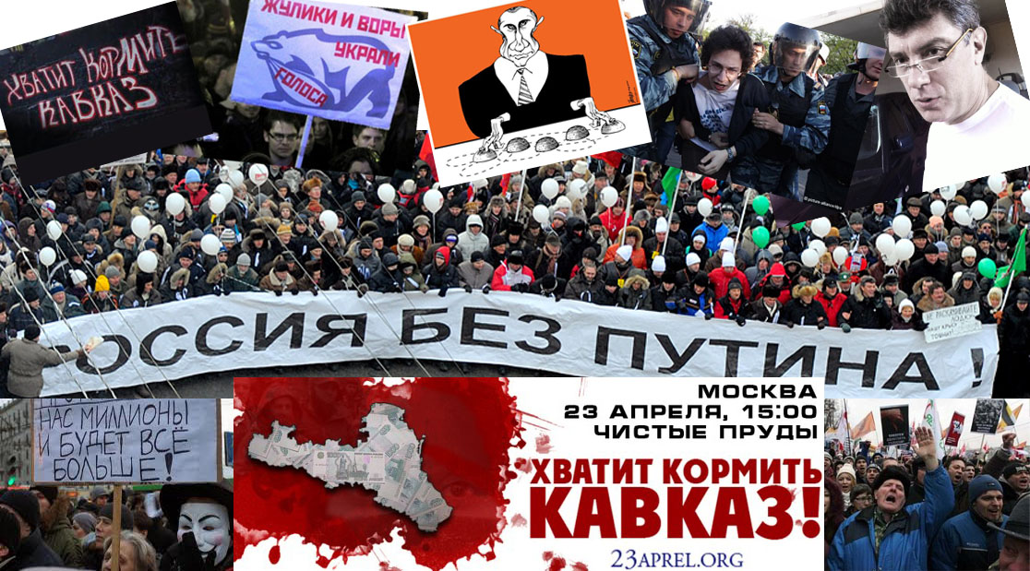
The regime cannot stop development of the anti-Putin movement. It cannot ban gatherings, and administrative, and now very often criminal prosecution, doesn’t help deter people anymore.
In essence Russia is ready for drastic changes and it is a few factors slowing the process.
The biggest is absence of proper leadership with a coherent strategy among the anti-Putinists, a strategy which should clearly postulate a “relinquishing” the North Caucasus (the slogan which is unspoken but implied by the use of “Enough feeding the Caucasus”)
Post-Putin’s Russia will inevitably have to grant independence to the republics of the North Caucasus. When this happens, we can also expect strong aspirations for sovereignty by the muslim republics of the Volga region. At this point, we are discussing the probability of the total collapse of Russia and its subsequent fragmentation along the borders of its ethnic Russian regions.
How will these events unfold? Will they be as smooth as the breakup of the Soviet Union, or will there be spots of civil unrest/violence? All this, of course, concerns the people of the Caucasus. Even more concerning, however, is unreadiness for the retreat of Russian authority in the region, being that the Russian Federation may cease to exist as we know it today.
Obviously, once decentrilization begins, the ideas emanated from the center (Putin’s Eurasian Union) will be discarded.

Expectations
In the beginning of my presentation, I briefly described the current situation of Circassia and its people. It appears that now we are urged to start discussions on the future of Circassia. How Circassians perceive it, which factors and priorities should be considered in order to reduce negative repercussions, and have more favorable chances for success in restoration of the Circassian state.
Even if we put aside the century and a half long dream of eventual unification and restoration of Circassians’ country, while their suffering the genocidal consequences in terms of hardships of repatriation, they must think about their own state. Otherwise, being unready, they might miss their chance again, as it happened in 1917 and 1991, when one authority changed to another without the participation of Circassians. And it’s specifically important for western Adyghea Republic’s Circassians and Adyghe segment of Circassians in Karachayevo-Cherkessia, as they are minorities there, and can be exposed to danger or even violence. An example that can be drawn to Krasnodarskiy Kray, which has an official anthem with such words as: “Against the enemy, against the moslem, we’re raising up for the mortal combat”. Nobody can give any guarantee of not using the violent means against Circassian minorities. Such a guarantee of protection against violence can only be made through their own statehood.

Different Approaches
If a few years ago it was unbelievable that Circassians would speak out loud about their state, this topic is certainly not a taboo any more. Activists propose quite ambitious projects.
Apparently, so far we can speak of 3 different approaches somehow dealing with the idea of restoration of Circassian statehood.
As a preliminary, we can conditionally call them in our terms.
- Mega Circassia
- Circassia – Greater Kabarda
- Democratic Circassia
In the beginning I have to mention that none of them has any detailed content, at least not to my knowledge. Right now we only can speak about tentative projects, discussing levels of reasonability.
Ideological inspirers of the first 2 approaches are from KBR. Publicly they haven’t yet had any disputes amongst each other regarding justifiability of their respective plans.
Here is the detailed description of these two approaches.
First is “Mega Circassia” a project ambitiously proposed by “Patriots of Circassia”, a newly established movement in Nalchik, which then stretched its affiliation into Turkey. The major points of this segment of Circassian society are
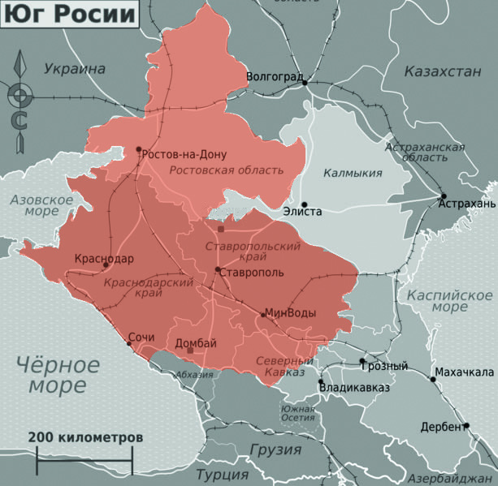
a) Perception of term Circassian as purely ethnic NOT IN TERMS OF THE CITIZENSHIP. (Emphasis!).
b) Equivalence of «шэрджэс = адыгэ». Exonym [a name given to a people by a secondary persons other than the people it refers to] “Circassian” foreign to Circassian language (адыгабзэ) is equalized with endonym [а name used by a people to refer to themselves in their language]. And thus, in any case of using word «адыгэ» can be implied to the other word “Circassian”. To be more precise, it was invented by the bolsheviks and artificially implanted into Circassian language in a form «шэрджэс». This state of matter is most remarkably reflected in the official name of Karachay-Cherkessia IN CIRCASSIAN LANGUAGE, instead of «Къэрэшэй-Адыгэ Республик» it goes as «Къэрэшэй-Шэрджэс Республик» which is obvious logical extension of the “divide and rule” policies.
Consciously or by the misunderstanding, “Circassian Patriots” digressed from the slogan “Endonym – Adyghe, Exonym – Circassian” (Самоназвание адыгэ, иноназвание - черкес), adopted by the International Circassian Association in early 90’s, and, de-facto, superseded it with “Endonym Adyghe is equal to Circassian» (Самоназвание «адыгэ», равносильно этнониму «черкес»).
Apparently this approach is erroneous and inacceptable. As it eventually either alienates native non-Adyghes (Abazas and Karachays) from Circassia, or alienates the historical genocide-cleansed Circassian lands later repopulated by Abazas and Karachays from Adyghes.
It’s broadly known that travelers also called Abazas and Karachay (Kara-Cherkesi) as Circassians, merely because they shared with Adyghes their Circassian state based on their mutual and identical lifestyle. They might not necessarily have called themselves Adyghe, but spoke Adyghe language . And another group of Circassians, Ubykhs, denoted themselves as Adyghes, while had besides Adyghabze their own language unintelligible for another Adyghes.
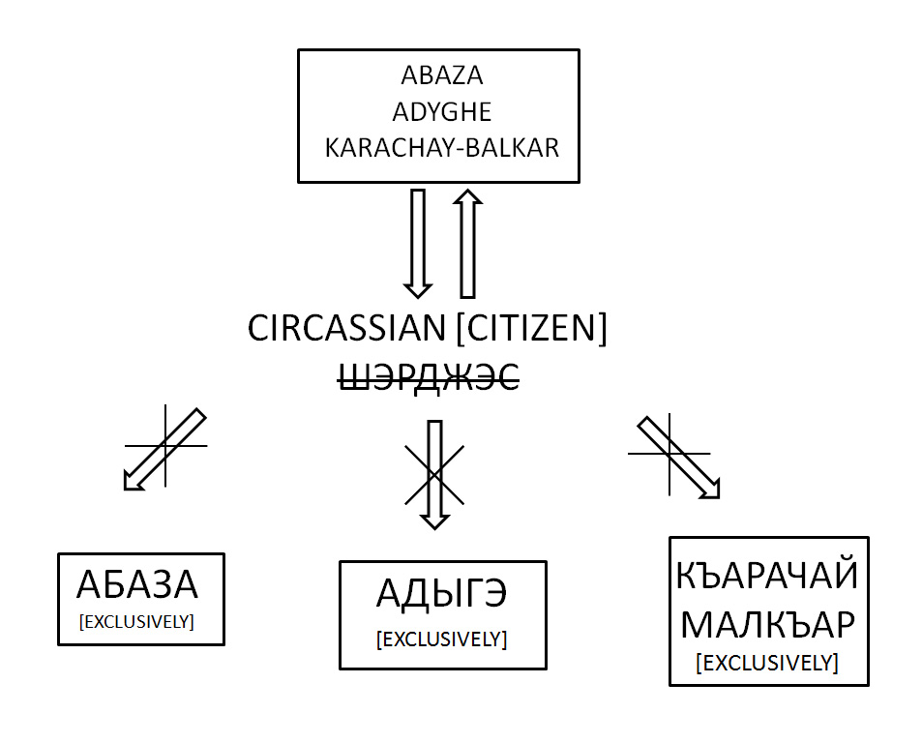
c) Point is claims for the territories far bigger than Circassia were at the time when Russia started to expand onto Adyghe lands. Those territories nowadays populated almost purely by the ethnic Russians (all the Krasnodarskiy Kray, Stavropolskiy Kray, and Rostovskaya Oblast). The lands which Circassians left long before the Russians came, and correspondingly there are but no diaspora descendants of exilees originated from there.
d) Ignoring of the indigenous rights of Karachay-Balkars and Abaza peoples in the proposed territories of Circassia, as well as ignoring Karachays’ domination in Karachayevo-Cherkessia. And as a result, absence of any ideas in regards of peaceful coexistence with them.
e) Ignoring the fact that Russian population in the territories of “Mega Circassia” constitute number of over 14 million people.
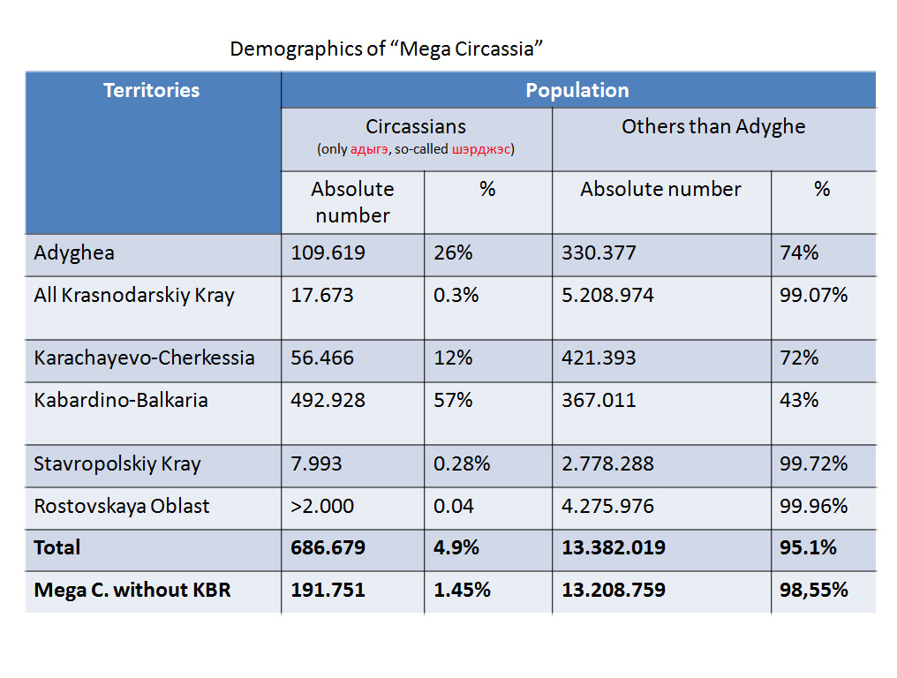
The demographics of proposed “Mega Circassia”. Project ridiculously promises 4,9% of Circassians [which include only Adyghes]. And correspondingly 95,1% non-Circassians. This picture turnes to be even greater ridicule if we’ll try to deduct population of KBR, the only subject of RF where Circassians constitute majority group. So, “Mega Circassia” without KRB will only include 1,45% ethnic Circassians and 98,55 non-Circassians.
Second approach “Circassia – Greater Kabarda” is not propagated so actively as the first, rather being kept at a low profile, but it does exist. Its main points are:
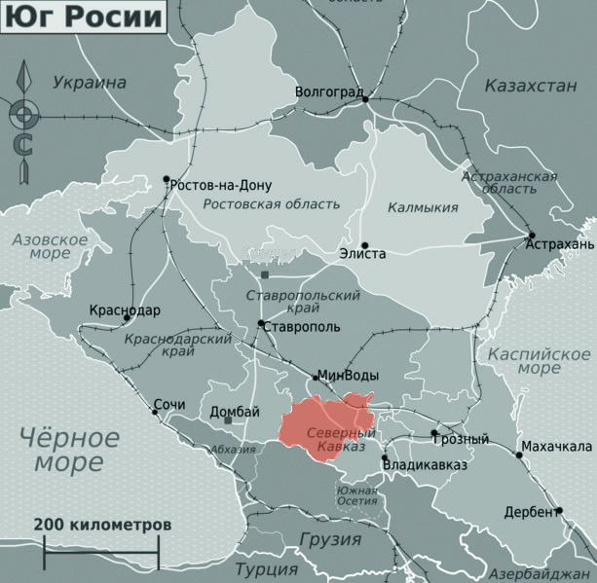
a) It totally coincides with the first point of “Mega Circassia” in terms of ethnonyms’ confusion. Adherents of “Circassia – Greater Kabarda” also perceive term “Circassian” as purely ethnical, not political.
b) Abandonment of any claims for the territories along the Black Sea shore is also one of notable cap stones of the theory. Instead, the Diaspora is being offered the territories with dominant Circassian population, precisely of modern KBR.
c) Absence of the explanation how several million of Circassians will be able to physically fit into Circassia-Kabarda, while additionally disregarding the fact that the diaspora’s majority are the descendants from western Circassia.
d) Ignoring of the Genocide and urge to overcome its consequences by the repatriation into the lands of their grandfather’s origins. Proposal of their financial participation, rather than their physical return en mass.
e) As a solution on the dominance of Karachays in KCR they optionally propose secession of the Circassian territories included by the bolsheviks into Karachay Autonomous Oblast, which was eliminated after deportation of the Karachays in1944 and never restored, but reformed into combining republic, which unifyed Adyghes and Karachays. This withdrawal however ignores the fact, that most of the Karachays live in KCR proper, outside of the borders of their former Autonomous Oblast. Such matter of things logically suggests that people supporting this approach are ready to give up with all of Karachayevo-Cherkessia.
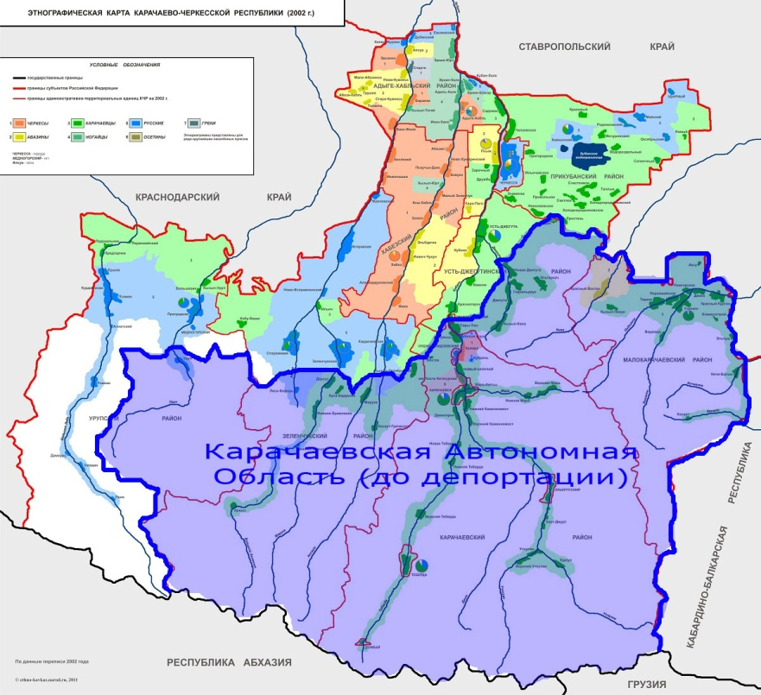
After one would precisely overview conditionally named approaches “Mega Circassia” and “Circassia – Greater Kabarda”, he will invariably conclude that both of them finally lead to Circassia in the borders of present KBR. Which has very slight chance to be realized smoothly without bloodshed, as barely any Circassian in the world would accept KBR as the only land of their country. And I don’t want to talk about possibilities of attempts to complete the genocide, by cleasing off the territories of Adyghea Republic and Karachayevo-Cherkessia from the remnants of Adyghe population.
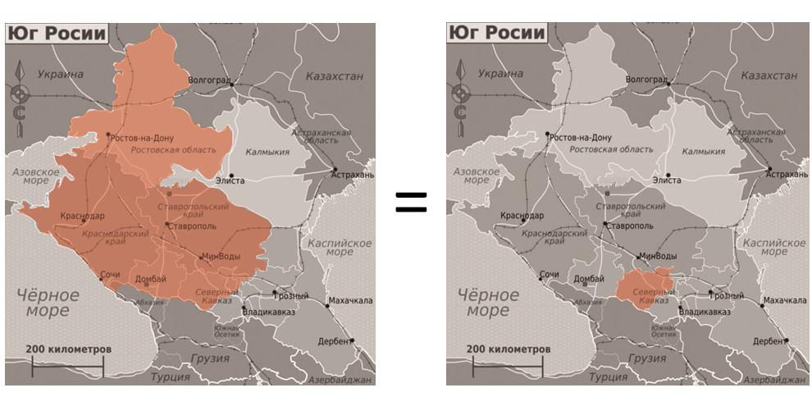

Danger of spreading of Monoethnic exclusiveness.
As I previously said monoethnic approach would create many complications during the process of restoration of Circassia. First among them should be mentioned the factor of masses of non-native population, majority of which not just don’t speak any of the native languages of Circassia, but barely acquainted with culture and traditions of the land they live in.
This happens because particularly ethnic Russian population lives in Circassia on sort of cyclical method, after 20-30 years part of the population re-emigrates on their own back to Russia. In return Russian authorities send families of retired militaries, granting them the appartments. This is broadly practiced in Adyghea Republic. And such policy is implemented in order to artificially keep the proportion of Russian population high in the conditions of abrupt democraphic declention throughout the Russia in general.
Circassian patriotic movement must realize, that agitation of the Adyghe exclusiveness, ignoring actually living on the Circassian lands population is assuredly fraught with negative consequences, such as aggravation of already existing antipathies towards Adyghes, building up fears among the non-Adyghe populace of practical realization of Circassia’s restoration project. Which in its turn may possibly cause regular people to hinder the Circassians’ effort, while total collaps of Russia, and reallocate their support towards another non-Circassian options of rebuilding new jurisdiction, where Circassians in their historical lands won’t be considered at all.
Everybody aware about attempts to re-write the history of Circassia. Besides the internecine noise between Abaza, Adyghe and Karachay-Balkars, territories of Circassia are actively being ascribed to Cossacks, Armenians and other peoples with clearly existing ancestral lands outside of the Circassia.
Monoethnic exclusiveness applied to the idea of Circassian state restoration does also contradicts to the existed historical reality, stating that besides Adyghes there always lived other ethnicities. Besides 3 major ones there were also known settlements of Greeks, Armenians and Christian Orthodox Nekrasovtsi Cossacks.
But what is even more important is fact that propaganda of ethnic exclusiveness based on arguable historical interpretations and momentary pseudo-patriotism isn’t understood in the modern world, mismatch to the universally recognized principles of peoples’ coexistance. Any civilized country striving to the freedom and true democracy should be guided by these principles. And that’s what absolutelly doesn’t exist in Putin’s Russia.

Democraric Circassia
Racional alternative to the monoetnic Utopia “Mega Circassia”, actually leading to the “Circassia – Greater Kabarda” can be only “Democratic Circassia” restored according to the bases existed in Circassia prior to the war and colonisation of 1763, 1822 and acts of Genocide of 1864.
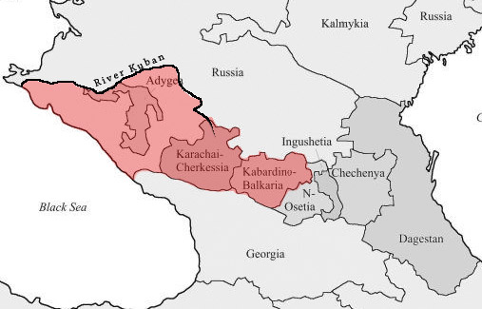
According to 2010 census, Circassians living in Circassia represented in administrative units of Russian Federation in following numbers: Adyghea 109.619 constituting 26%,
Krasnodarskiy Kray territories bordered by the left bank of the Kuban River (correponds historical border before Russian invasion), KChR on the East, and Black Sea coast from the Kuban mouth to the River Psow, Constituting 14 regions (rayon): Anapa, Novorossiysk, Krymskiy, Gelenjik, Abinskiy, Severskiy, Tuapsinskiy, Goryache-Kluchevskoy, Bolorechenskiy, Apsheronskiy, Labinskiy, Otradnenskiy, Mostovskoy and Bigger Sochi.
In this area of Circassia as a result of total Genocide, Circassians constitute less than 1% (about 17 thousands) of total population of 1.84 million.
Karachayevo-Cherkessia is 61% of native Circassians combining Karachay, Adyghe and Abaza and in Kabardino-Balkaria 70% Circassians combining Adyghe and Balkars. Totally in the present time Circassians living within the Circassian proper of 3 republic of the Nothern Caucasus and Krasnodarskiy Kray south from Kuban River would be about reasonable 39% (compare with 4.9% of aggresively agitated Mega Circassia).
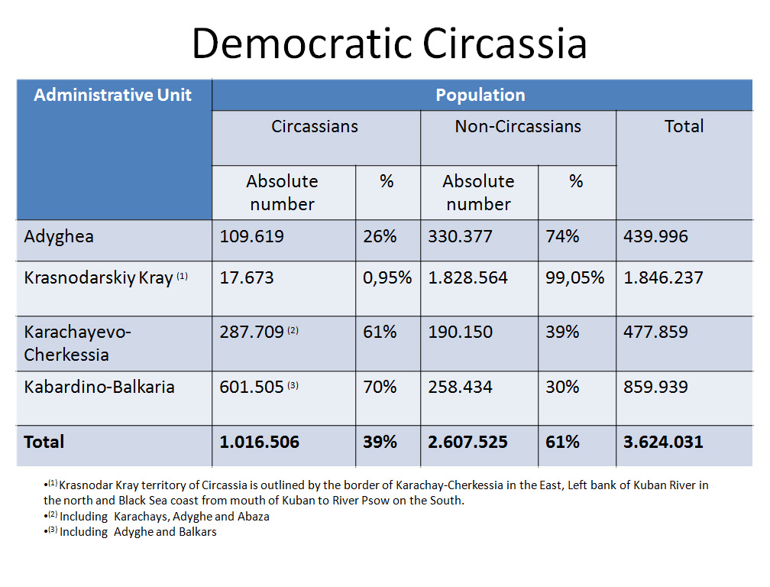
And the last thing I would add is my ideas about mutual future of Circassia within the brotherly family of the Caucasian nations. All the people in our area shared a lot of things in common, were always very close to each other. And this matter of fact should be somehow intitualized in the future. Would that be an association or perhaps the Commonwealth of the independent Caucasian states.
Thank you for your attention.

